Task 1: Customer Data Loading & Exploration
Objective:
To load the customer dataset and understand its structure using Python.
Code:
import pandas as pd
import numpy as np
import matplotlib.pyplot as plt
import seaborn as sns

df = pd.read_csv("ecommerce_customer_data_large.csv")

print("First 5 rows:")
display(df.head())

print("\nDataset Info:")
print(df.info())

print("\nColumn Names:")
print(df.columns)

print("\nStatistical Summary:")
display(df.describe())

print("\nMissing Values:")
print(df.isnull().sum())

df = df.dropna()

df = df.drop_duplicates()

print("\nAfter Cleaning Shape:", df.shape)

df["Calculated_Total"] = df["Product Price"] * df["Quantity"]

df["Purchase Date"] = pd.to_datetime(df["Purchase Date"])

plt.figure()
sns.histplot(df["Age"])
plt.title("Age Distribution")
plt.show()

plt.figure()
sns.histplot(df["Total Purchase Amount"])
plt.title("Total Purchase Distribution")
plt.show()

plt.figure()
sns.barplot(x="Gender", y="Total Purchase Amount", data=df)
plt.title("Gender vs Spending")
plt.show()

plt.figure()
sns.countplot(x="Product Category", data=df)
plt.xticks(rotation=45)
plt.title("Product Category Distribution")
plt.show()

from sklearn.cluster import KMeans

X = df[["Age", "Total Purchase Amount"]]

kmeans = KMeans(n_clusters=3)

df["Cluster"] = kmeans.fit_predict(X)

plt.figure()
sns.scatterplot(x=df["Age"], y=df["Total Purchase Amount"], hue=df["Cluster"])
plt.title("Customer Segmentation")
plt.show()

plt.figure()
sns.countplot(x="Churn", data=df)
plt.title("Churn Analysis")
plt.show()

print("\nFinal Dataset with Clusters:")
display(df.head())

Output:
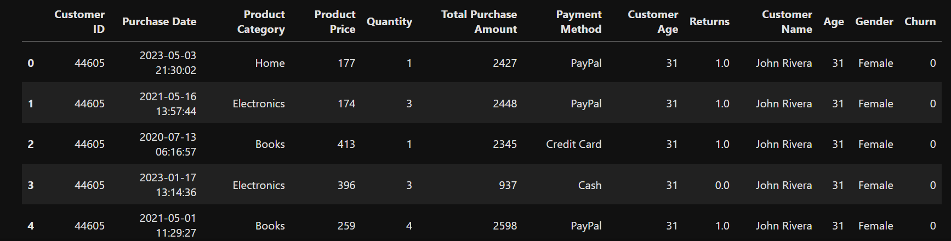
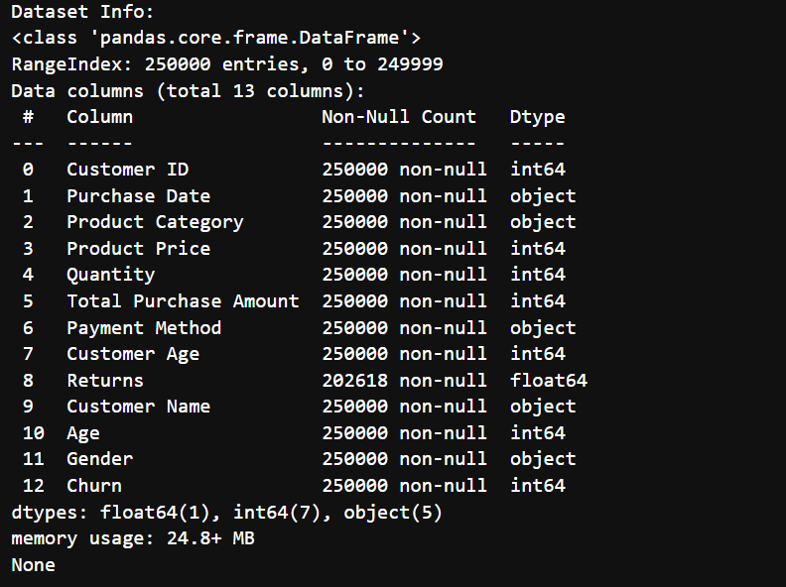
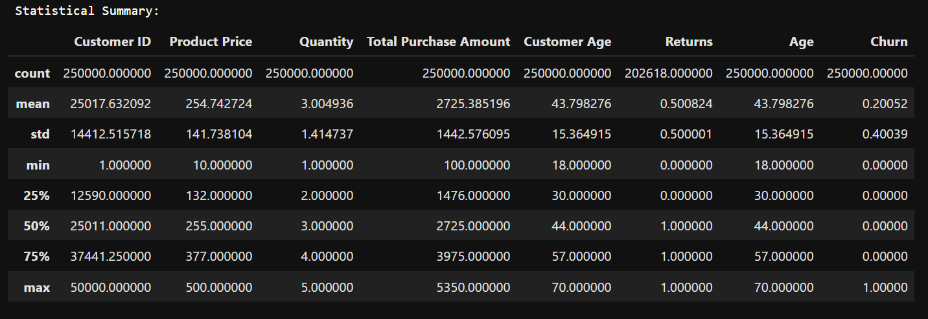

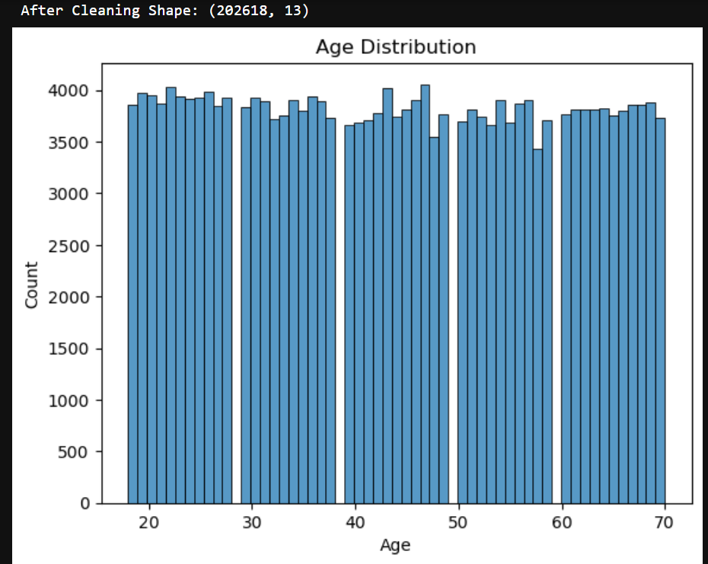
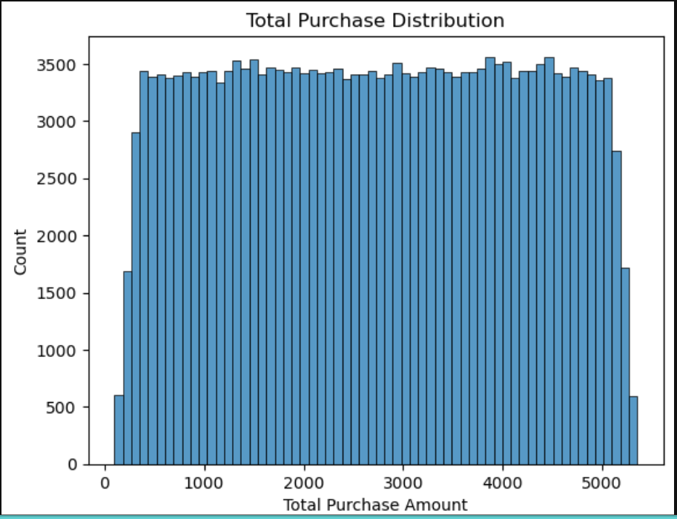
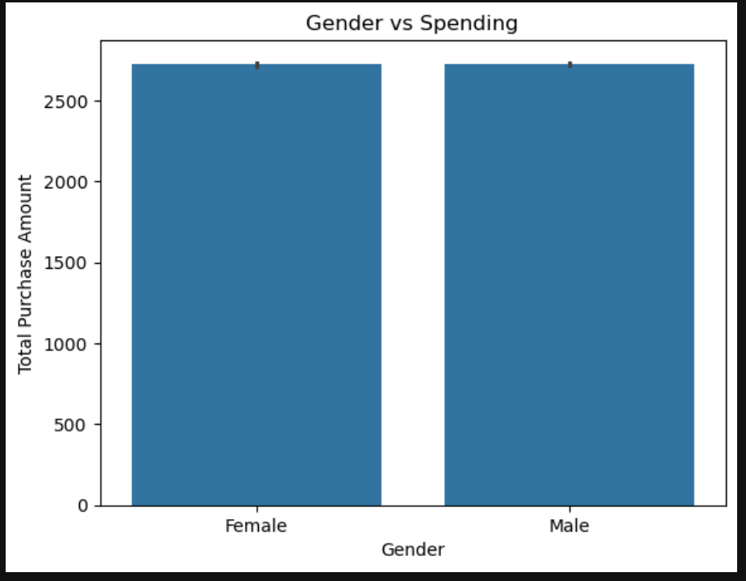
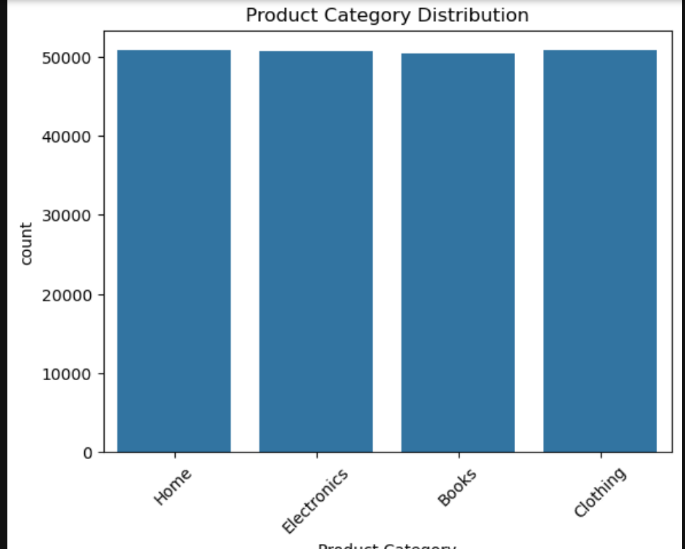
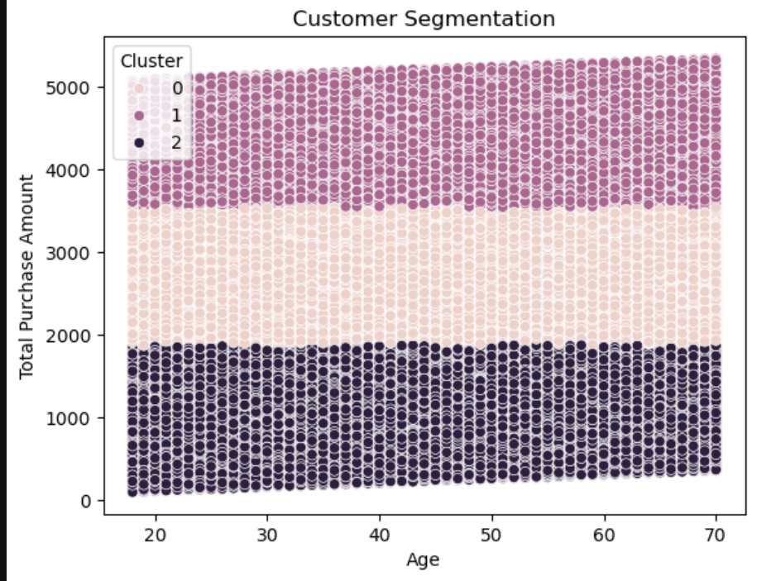

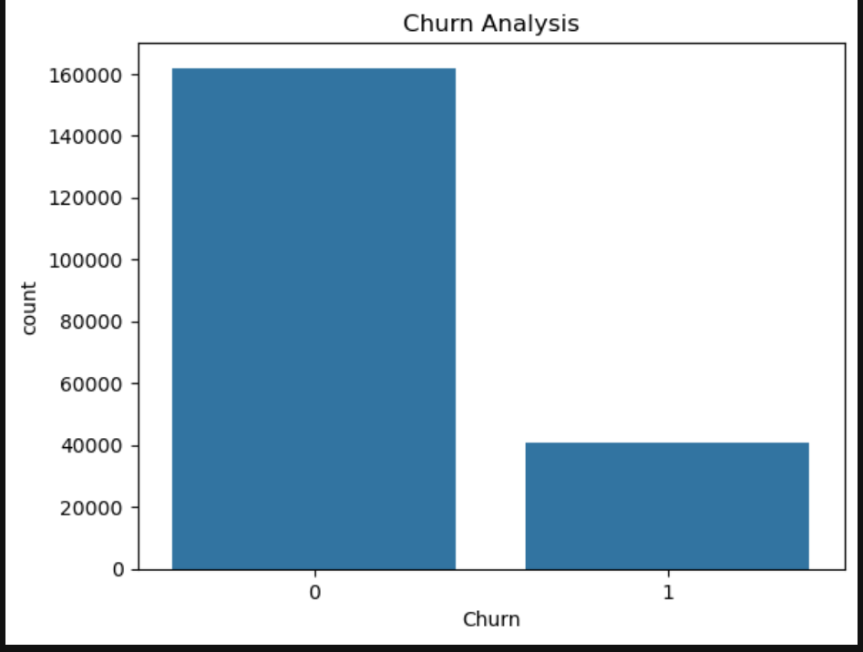
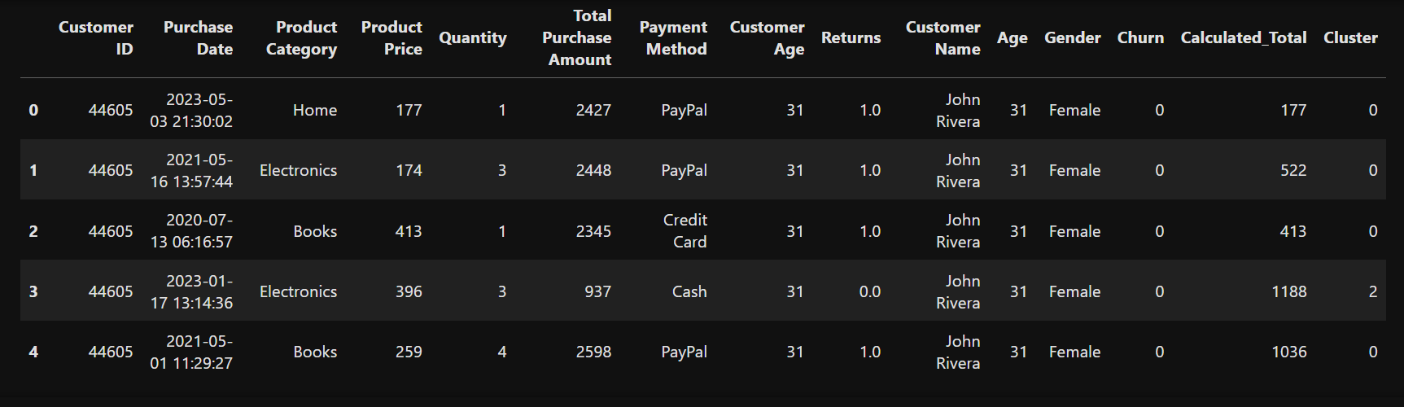
Summary:
In this task, the dataset was successfully loaded using Python. Basic exploration techniques such as viewing the first few rows, checking column names, and understanding the dataset shape were performed. This step helped in understanding the structure and preparing the data for further analysis.

